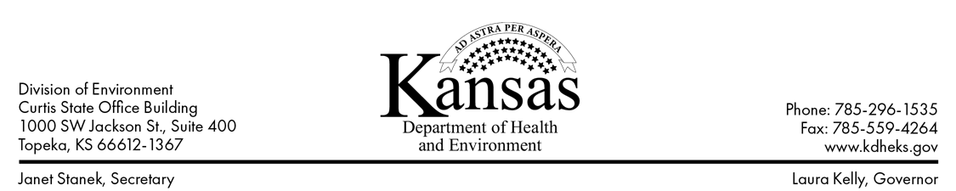

For Immediate Release
October 28, 2022

For more information, contact:

Matthew Lara
matthew.lara@ks.gov
785-296-1317

Boil Water Advisory Rescinded for the City of Galena, Cherokee County
TOPEKA – The Kansas Department of Health and Environment (KDHE) has rescinded a boil water advisory for the City of Galena public water supply system located in Cherokee County. The advisory was issued because of a loss of pressure in the distribution system. Failure to maintain adequate pressure may result in a loss of chlorine residuals and bacterial contamination.
Public water suppliers in Kansas take all measures necessary to notify customers quickly after a system failure or shutdown. Regardless of whether it’s the supplier or KDHE that announces a boil water advisory, KDHE will issue the rescind order following testing at a certified laboratory.
Laboratory testing samples collected from the City of Galena indicate no evidence of bacteriological contamination and all other conditions that placed the system at risk of contamination are deemed by KDHE officials to be resolved.

For consumer questions, please contact the water system at 620-783-5265 or you may call KDHE at 785-296-5514. For consumer information please visit KDHE’s PWS Consumer Information webpage:
kdhe.ks.gov/waterdisruption

###

